## Communication, Interaction, and Cognition

* Computing has been one of, if not the most, important disruptive technologies (innovations that create a new market and value network that eventually disrupts an existing market and value network) of the modern age.
  + Computing enhancements include SMS, email, video calls, chatrooms, crowdsourcing, e-commerce, and distributed solutions.
    - Such advancements have allowed humanity to innovate at exponential rates and generate data faster than ever before.

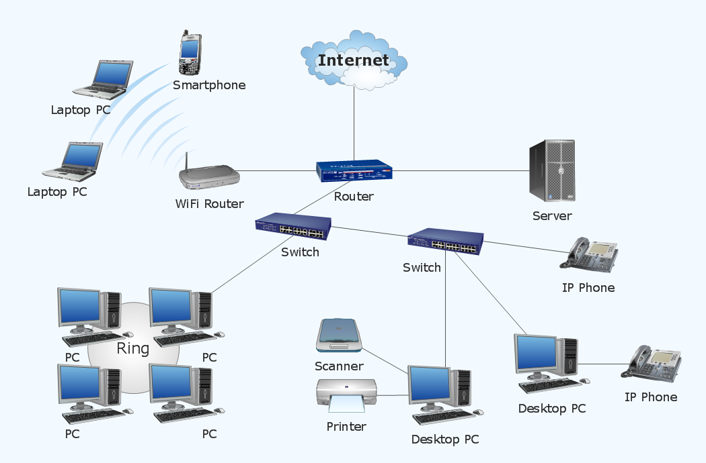

## Instant Communication

In 2019, 293.6 billion emails were sent each day (statista.com), which is more than all of the snail-mail sent in the US over the past two years (facts.usps.com). Social media has generated so much data that groups like Cambridge Analytica have been able to manipulate in unscrupulous and amazing ways. Instant communication has also allowed us to innovate in ways previously unavailable via crowdsourcing and “citizen science,” which have made projects of formerly insurmountable scope achievable.

A commonplace example of the collaboration made possible by instant communication is Google Docs. Two people typing on the same document from thousands of miles away while chatting with each other over the phone is only possible thanks to modern computing. Another is the Global Positioning System, or GPS, that we use to navigate on a daily basis.

## Enhanced Interaction

Flying overseas on a whim, ordering anything from computer parts to groceries online to be delivered, and the ability to stream hundreds of thousands of shows and movies instantly are all things possible thanks to modern computing. We now have the ability to interact with people, places, and concepts far beyond our previous scopes. Computing also helps increase the quality of life in many ways in such ways as smart buildings, structures with centralized control of heating, ventilation, air conditioning, and lighting.

## Cognition

Humans have always been innovators. It is what allowed us so much success as a species. Our ability to work together to solve problems has always been our greatest boon and computers serve to multiply that boon tenfold. Cloud computing fosters new ways to collaborate and crowdsourcing allows anyone to contribute their knowledge to a solution.  
 One example of an interesting crowdsourcing is Zooniverse’s Moon Zoo project. This project allows anyone who wishes to organize and study high-resolution lunar images ([zooniverse.org](https://www.zooniverse.org/)).

## Resources

* For more information on Cambridge Analytica
  + <https://en.wikipedia.org/wiki/Cambridge_Analytica>
* For more information on how the internet works
  + <https://web.stanford.edu/class/msande91si/www-spr04/readings/week1/InternetWhitepaper.htm>
* For more information on Zooniverse
  + <https://www.zooniverse.org/>

## Vocabulary

* Disruptive Innovation
* Crowdsourcing
* Cambridge Analytica
* Citizen Science
* Smart Buildings